Report on Visit to Sierra Leone
March 2026

Around 30 years ago, a friend of mine started a charity to help mature Christian organizations in his home country of Sierra Leone, West Africa. Sierra Leone experienced a terrible civil war from 1990 to 2001 which devastated its people, its economy and the basic service availability for all his countrymen. He had moved to the US but could not live with the terror that had destroyed his country, so he started this charity. I’ve known him for 30 years, and been on the Board of the charity for almost 20 years. We travel to Sierra Leone every 2-3 years to meet with our partners to see what’s really going on, and how we can help.

With that in mind, I traveled with him, and we met with each of our five Christian ministry partners. But the highlight of the trip was traveling to the northernmost border areas of Sierra Leone. Our charity had acquired the Jesus Film Backpack for our partner (with support from Zionsville Fellowship) and they were taking the film to the most remote villages in the country where the name of Jesus had never been heard. So we drove four hours on paved roads and another 4 on dirt roads that sometimes were more like paths to visit three villages where the Jesus Film had been shown, and members of this people group (the Susu people) had accepted Christ after watching the film.

As we pulled into the first village, the local believers came and surrounded us and were so full of joy, it was unmistakable. But these people had NOTHING of what we could call basic things: no
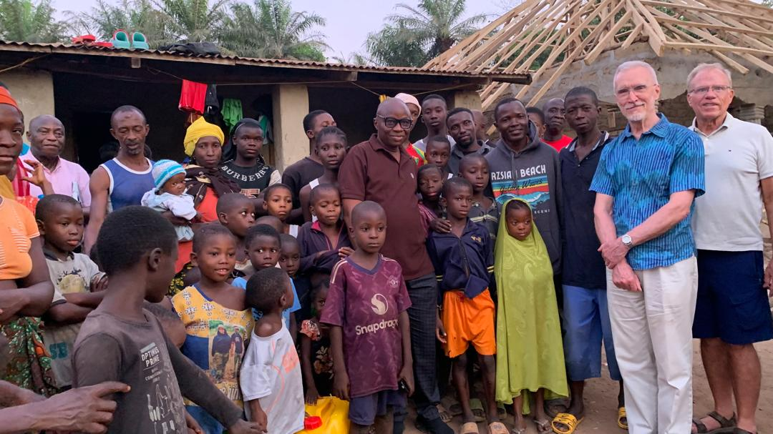

electricity, no plumbing (only outside latrines), no cell phones and oftentimes no cell service. Yet despite what they lacked, they now had Jesus. They clapped and sang for us in their language, and we spoke to them and encouraged them and prayed for them through translators. It seemed possible these villagers had never actually seen white people before, but they were so accepting of us and wanted to touch us and love on us. I was truly overwhelmed. This village now had a small man-made tent (in the background in the above picture) that served as their church, and the group of about 30-40 people understood their freedom in the Gospel. I was moved to tears by their joy. It reminded me of Nehemiah 8:10 that says “the joy of the Lord is your strength!”
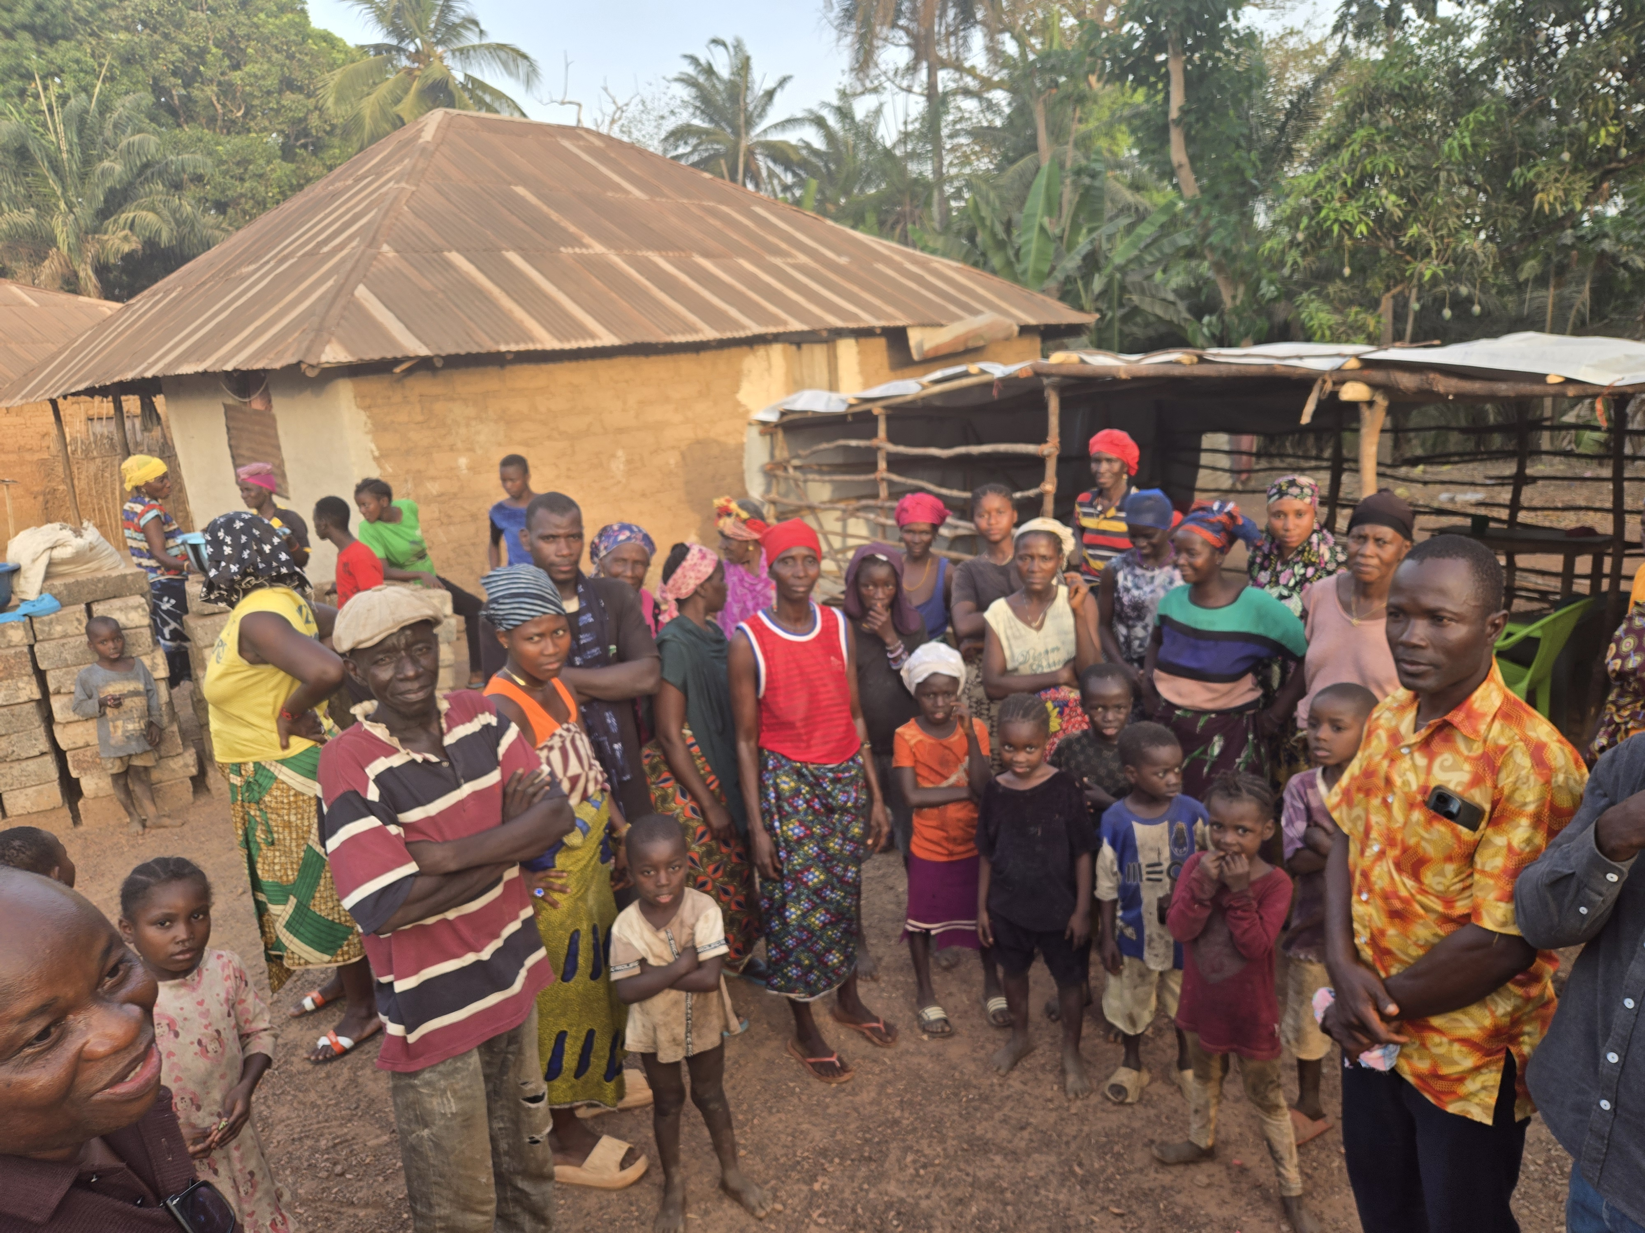
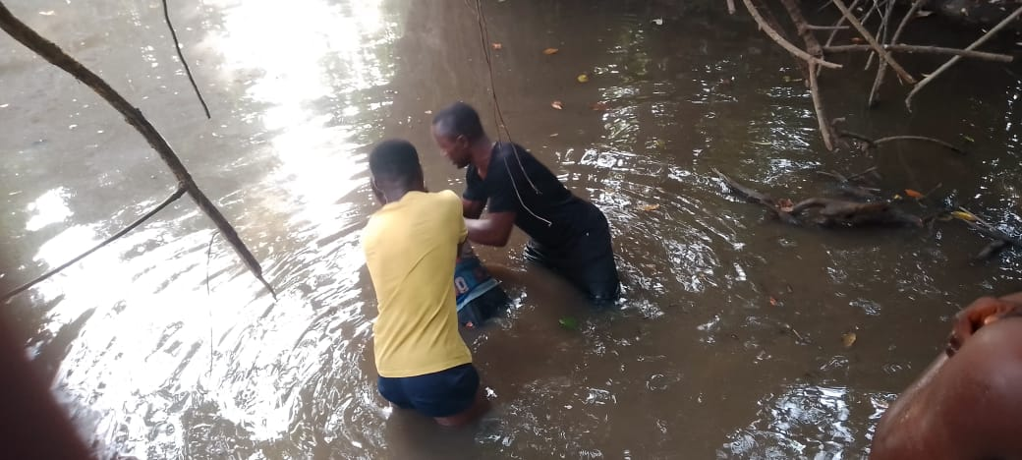

We traveled to another village, even smaller (about 300 people) where the Jesus Film had been shown. A “person of peace” was identified who would host a Bible Study where they could learn more about what they saw in the movie. Again, these villagers were so excited to see us and learn more about Jesus. A group of about 15-20 circled us as we again prayed for them and encouraged them in the Lord. You can see a local baptism, which happens after they have been taught about what it means to believe in Jesus and be called by His Name.

Finally we reached the third village where the Jesus Film was to be shown for the second or third time. Hundreds of villagers walked through the dark to come to the local primary school yard where the showing took place. At the end they were again asked if they wanted to believe in Jesus or learn more about them and many responded. This is a larger village of over 800, and as many as 300 now were claiming Christ! At the end of the evening they made the declaration that the name of their primary school was going to be changed to the village “Christian” primary school. The village headman was there and he approved of the change. The Lord is at work in the Susu people, and the Jesus Film has been the tool through which these beautiful souls are finding the joy of Jesus. You can see in this picture that the villagers can’t always make it to the stream for baptism!
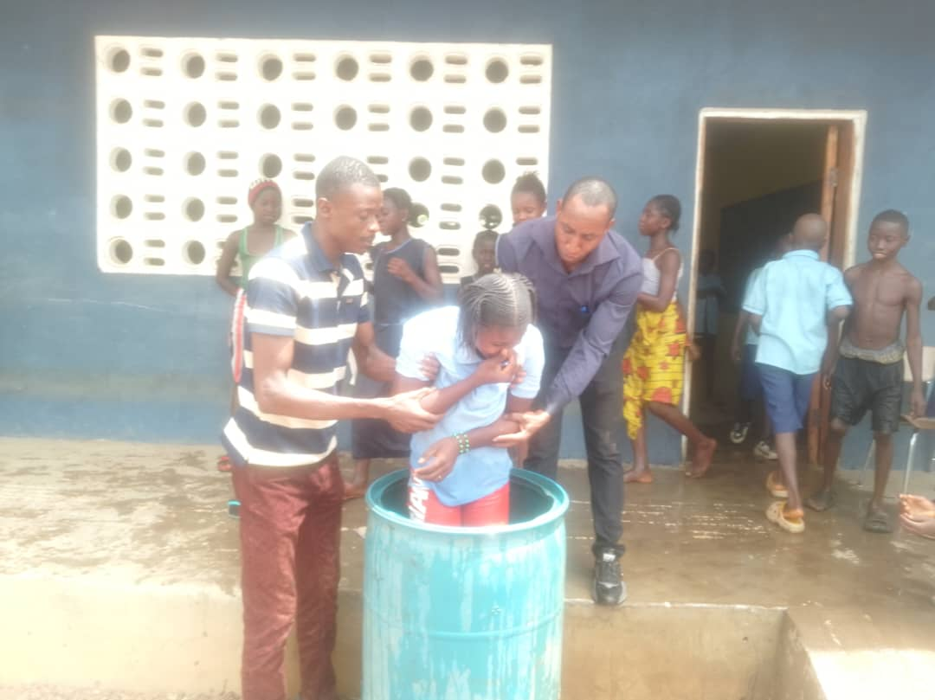

While our meetings with partners continued on, I will not soon forget the joy on the faces of so many remote villagers on the Sierra Leone / Guinea border, definitely the highlight of this visit to Sierra Leone!

Larry Moran with SAVE, Inc. (savesierraleone.org)

